**Digital skills and VET in Romanian EU Presidency’s programme**

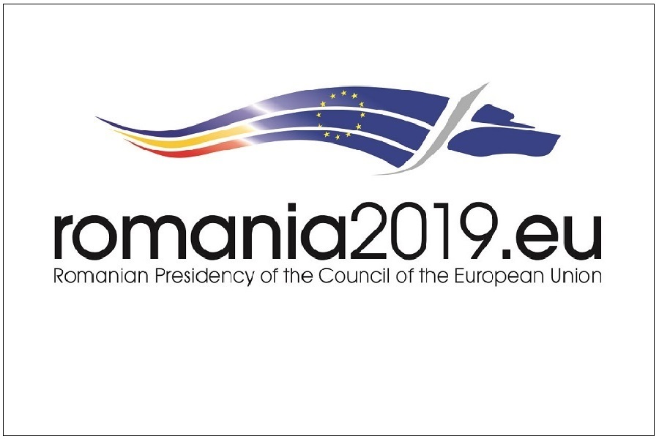

**Image copyright:**

@romania2019.eu

**Romania has taken over the rotating six-month EU Presidency for the first time. Its programme, published on 15 January, focuses on ‘cohesion, a common European value’ and includes provisions for vocational education and training (VET), digital skills and mobility.**

[**The programme**](https://www.romania2019.eu/wp-content/uploads/2017/11/en_rogramme_ropres2019.pdf) is mainly future-oriented stating that ‘innovation and research contribute to job creation, and help increase companies’ competitiveness on global markets, improve people’s quality of life and generate sustainable economic growth.’ It makes the case for ‘a significant decrease of the digital gap between Member States, regions, categories of European citizens, and industrial sectors.’ It calls for special attention ‘to developing and implementing measures to improve digital skills and digital literacy, including by making this a long-term priority for the EU.’

Digital transformation and artificial intelligence will define future industrial policies. To develop adequate capabilities, the Presidency encourages debates ‘on the opportunities and challenges of artificial intelligence on the one hand and, on the other hand, on the development of digital skills and digital literacy, with a view to reducing digital gaps and increasing social and economic inclusion, as well as increasing investments in education and performance in STEM (science, technology, engineering and maths).’

According to the Presidency programme, ‘mobility is an important pillar of the European project and of the promotion of common values, the development of skills and the integration of citizens into the labour market.’ It that context, there is a need ‘to identify measures that can contribute to closing the gaps in terms of access to educational, volunteering or vocational training opportunities, including for young people.’ It adds that learning mobility ‘contributes to the development of professional competences and skills, as well as to increasing employment opportunities.’

The Presidency will continue discussions on the proposal for a Regulation on the Erasmus+ Programme,**‘**with a view to agreeing a programme that favours inclusion and that will contribute to increasing the mobility of pupils, student, teachers and administrative staff, as well as to promoting European values through education.’ Special attention will be given to ‘establishing and developing European universities’ networks and centres of excellence in vocational and technical education.’

Regarding the contribution of education to the European Union’s cohesion and competitiveness, the Presidency ‘will act to reach a consensus of the ministers of education on the Council Recommendation on a comprehensive approach to language teaching and learning. Foreign-language learning may be stimulated by the use of digital tools, aiming to increase pupils’, students’ and staff mobility and developing an inclusive cultural environment. Learning foreign languages can contribute to: increasing employability, social inclusion, active citizenship and personal fulfilment.’

The **[programme of the trio of EU Presidencies](https://www.romania2019.eu/trio-programme/)** in the next 18 months (Romania, Finland and Croatia) has also been published. It includes a special mention of the continued efforts needed to reintegrate the long-term unemployed in the labour market, to help young people develop the skills needed to become active on the labour market and to increase female participation. The three Presidencies will also take forward the implementation of policies tackling skill mismatch.